**What is Sigmoid Function?**

In mathematical definition way of saying the sigmoid function take any range real number and returns the output value which falls in the range of **0 to 1.**Based on the convention we can expect the output value in the range of **-1 to 1.**

The sigmoid function produces the curve which will be in the Shape **“S.”**These curves used in the statistics too. With the cumulative distribution function (The output will range from 0 to 1)

**Properties of Sigmoid Function**

* The sigmoid function returns a real-valued output.
* The first derivative of the sigmoid function will be non-negative or non-positive.
  + **Non-Negative:** If a number is greater than or equal to zero.
  + **Non-Positive:** If a number is less than or equal to Zero.

**Sigmoid Function Usage**

* The Sigmoid function used for **binary classification** in logistic regression model.
* While creating artificial neurons sigmoid function used as the **activation function**.
* In statistics, the **sigmoid function graphs** are common as a cumulative distribution function.

**Implementing Sigmoid Function In Python**

* The function will take a list of values as an input parameter.
* For each element/value in the list will consider as an input for the sigmoid function and will calculate the output value.
* The code **1 / float(1 + np.exp(- x))**is the fucuntion is used for calcualting the sigmoid scores.
* Next, we take a list sigmiod_inputs having the values 2,3,5,6 as an input the function we implemented to get the sigmoid scores.

**Creating Sigmoid Function Graph**

Now let’s use the above function to create the graph to understand the nature of the sigmoid function.

* We are going to pass a list which contains numbers in the range 0 to 21.
* Will compute the sigmoid scores for the list we passed.
* Then we will use the outputs values to visualize the graph.

**Graph**

On successfully running the above code the below image will appear on your screen. If the above code failed in your system. Check the [machine learning packages](https://dataaspirant.com/2014/11/01/python-packages-for-datamining/) setup.

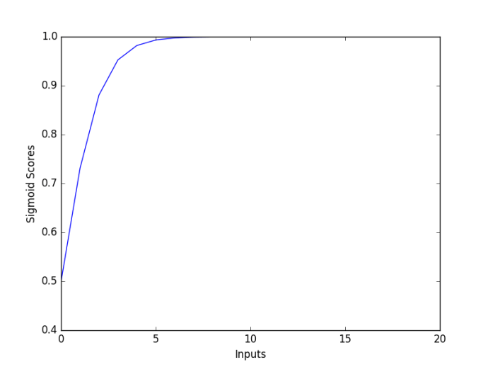

**Sigmoid graph**

From the above graph, we can observe that with the increase in the input value the sigmoid score increase **till 1**. The values which are touching at the top of the graph are the values in the range of **0.9 to 0.99**

**What is Softmax Function?**

Softmax function calculates the probabilities distribution of the event over ‘n’ different events. In general way of saying, this function will calculate the probabilities of each target class over all possible target classes. Later the calculated probabilities will be helpful for determining the target class for the given inputs.

The main advantage of using Softmax is the output probabilities range. The range will **0 to 1**, and the sum of all the probabilities will be **equal to one**. If the softmax function used for multi-classification model it returns the probabilities of each class and the target class will have the high probability.

The formula computes the **exponential (e-power)** of the given input value and the **sum of exponential values** of all the values in the inputs. Then the ratio of the exponential of the input value and the sum of exponential values is the output of the softmax function.

**Properties of Softmax Function**

Below are the few properties of softmax function.

* The calculated probabilities will be in the range of 0 to 1.
* The sum of all the probabilities is equals to 1.

**Softmax Function Usage**

* Used in multiple classification logistic regression model.
* In building neural networks softmax functions used in different layer level.

**Implementing Softmax Function**

If we observe the function output for the input value 6 we are getting the high probabilities. This is what we can expect from the softmax function. Later in [classification task](https://dataaspirant.com/2016/09/24/classification-clustering-alogrithms/), we can use the high probability value for predicting the target class for the given input features.

**Graph**

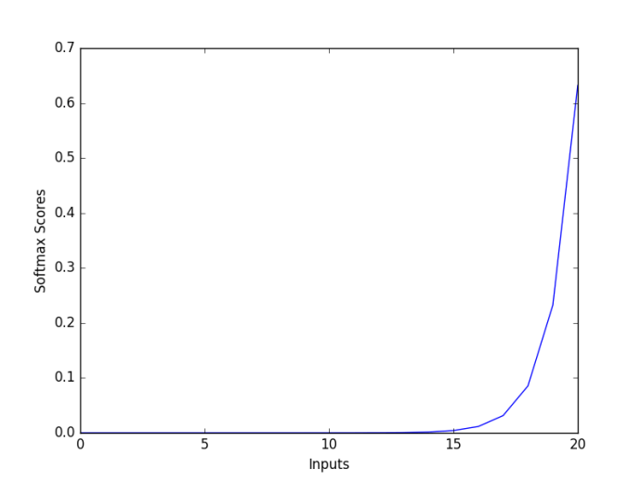

**Softmax Graph**

The figure shows the fundamental property of softmax function. The **high value will have the high probability**.

**Difference Between Sigmoid Function and Softmax Function**

The below are the tabular differences between Sigmoid and Softmax function.

|  |  |  |
| --- | --- | --- |
|  | **Softmax Function** | **Sigmoid Function** |
| 1 | Used for multi-classification in logistic regression model. | Used for binary classification in logistic regression model. |
| 2 | The probabilities sum will be 1 | The probabilities sum need not be 1. |
| 3 | Used in the different layers of neural networks. | Used as activation function while building neural networks. |
| 4 | The high value will have the higher probability than other values. | The high value will have the high probability but not the higher probability. |

**Conclusion**

In this article, you learn in details about two functions which determine the [logistic regression model](https://dataaspirant.com/2017/03/02/how-logistic-regression-model-works/). Just for a glance.

* **Softmax:** Used for the multi-classification task.
* **Sigmoid:** Used for the binary classification task.